Worksheet 4: Input devices

**Task 1 Keyboards, pointing devices and microphones**

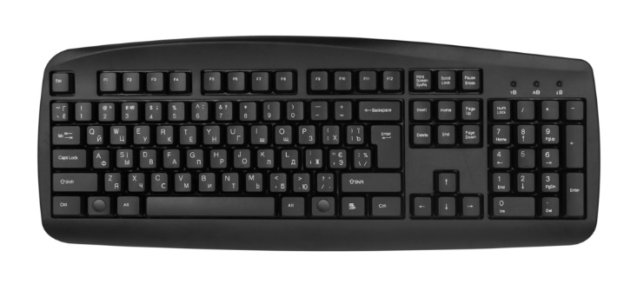

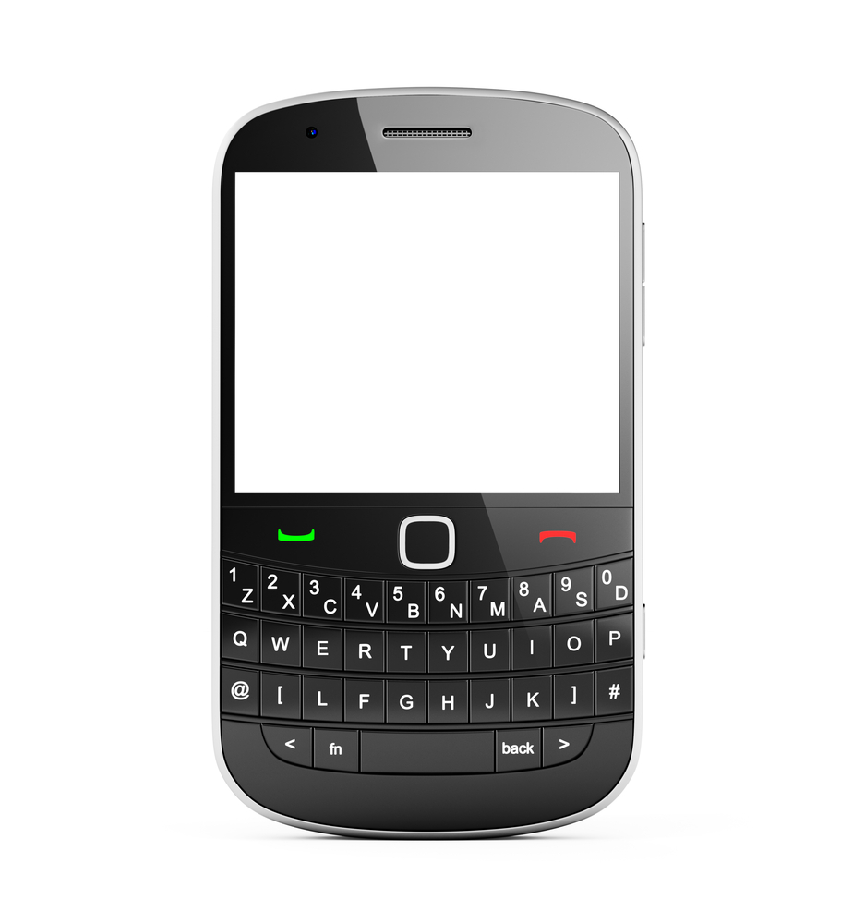

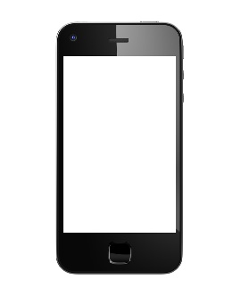

1. For this task you need access to, or experience of using, a PC or laptop mechanical keyboard, a tablet with a touchscreen keyboard and a mobile phone with mechanical keyboard and/or touchscreen keyboard.

Type the following into each of the devices using the keyboards:

*TABLETS and MOBILE PHONES often use “virtual” keyboards or touchscreens to enter data. Repairs to the screens can cost $60.00 or more.*

*PCs and laptops use “mechanical” keyboards. These can be wireless (no physical connection) and it is usually cheaper to replace a keyboard than to repair it. Typical replacement cost is £35.00*

On completion of the typing, make notes about the following:

1. How many errors you made using each type of keyboard
2. How easy it was to type in the text using each keyboard
3. The time taken to type in the text using each keyboard

What do you conclude? Give situations in which a touchscreen would be a suitable input device, with reasons.

2.

 

The person in the diagram is giving verbal commands to a computer using a microphone and built-in analogue-to-digital converter.

What problems might occur using speech recognition in this application? Name some situations in which this system would be useful, and some in which it would be impractical, giving reasons in each case.

**Task 2 Touchscreen technologies**

1. Some modern mobile phones use what is known as OLED (Organic Light Emitting Diode) technology – this allows the screen to be curved.

Mobile phones that use this technology have what are known as AMOLED displays.

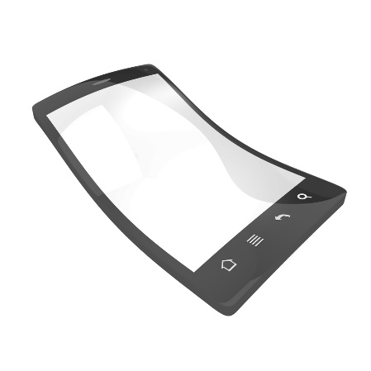

Find out the key advantages of this new technology compared to LCD screens.

(The following website link may be useful to you:

<http://www.oled-info.com/oled-mobile-phones>)

**Task 3 Use of sensors in real life applications**

Look at the following list of sensors. Then complete the table to show which type of sensor is the most appropriate for the group of applications shown in column 2 of the table. Each type of sensor should only be used ONCE.

**List of sensors:**

**Acoustic Moisture/Humidity**

**Gas pH**

**Infra-red Pressure**

**Light Temperature**

|  |  |
| --- | --- |
| **Type of sensor** | **Applications** |
|  | * control the central heating system in a house * control or monitor the heat output in a chemical process * control or monitor the environmental temperature in a greenhouse |
|  | * control or monitor the dampness of soil in a greenhouse * control or monitor the dampness of the air in a greenhouse * monitor the dampness levels in a factory making microchips |
|  | * switch street lighting on and off at dusk and dawn * automatically switch a car’s headlights on when it gets dark * to close or open the greenhouse blinds to maintain light levels |
|  | * turn on a car’s windscreen wipers automatically when it starts to rain * detection of intruders in a burglar alarm system * count the number of people entering or leaving a supermarket |
|  | * detection of intruders in a burglar alarm system * checking the weight of a vehicle on a weigh bridge * measurement of air pressure to forecast weather |
|  | * pick up noise levels (e.g. footsteps) in a burglar alarm system * detect the noise of liquids dripping from a pipe in an oil refinery * monitor the sound levels in a car factory |
|  | * monitor CO2/O2 levels in a river * monitor CO2/O2 levels in the air in a greenhouse * check for the carbon monoxide levels in a car exhaust system |
|  | * monitor or control the acidity levels in a chemical process * measurement of pollution levels in a river * check acidity levels in the soil in a greenhouse |

**Task 4 Monitoring and control using sensors**

Decide whether the following applications are examples of monitoring or control. Tick (**✓**) either column 2 (Monitoring) or column 3 (Control), for each application, to indicate your choice.

|  |  |  |
| --- | --- | --- |
| **Application** | **Monitoring** | **Control** |
| Automatically turning street lights on at night and off during the day |  |  |
| Changing the traffic lights at a junction to control the traffic flow |  |  |
| Keeping track of a patient’s vital signs (e.g. heart rate, temperature) in a hospital |  |  |
| Regulating the temperature in an air conditioning system |  |  |
| Checking for intruders in a burglar alarm system |  |  |
| Keeping track of the pollution levels in a river |  |  |
| Ensuring that the anti-lock braking system in a car works effectively |  |  |

**Task 5 Example of a monitoring system**

This monitoring system uses sensors and a computer to monitor the pollution levels in a river. The sensors send data to an interface box from where it is transmitted to a central computer.

The system uses oxygen level sensors and pH sensors. The people in the control room are monitoring for:

* Oxygen levels in the river falling below 15%, and
* pH levels in the river going outside the range 6 to 8

Explain how the system can be used to show any trends so that action can be taken before pollution levels are exceeded.

**Task 6 Example of a control system**

Street lamps switch on when it becomes dark and switch off again when it becomes light. Name an input device that could be used for this application.

What are the possible problems that could arise from the use of this input device? How could they be overcome?